Plants in our Pollinator Garden
Plants
Common Name | Botanic Name
Butterfly Weed | Aesclepias tuberosa
Purple Cone Flower | Echinacea ‘Magnus’
Bluestar | Amsonia hubrectii
Blue Grama Grass | Boutelou ‘Blonde Ambition’
Muhly Grass | Muhlinbergia
Salvia | Salvia ‘May Night’
Purple Aster | Aster ‘Purple Dome’
Coreopsis | Coreopsis ‘Zagreb’
Bluestar | Amsonia ‘Blue Star’
Aster | Aster ‘October Skies’
Phlox | Phlox ‘Jena’
Cone Flower | Echinacea ‘Sunshine’
Grasses
Common Name | Botanic Name
Switchgrass | Panicum ‘Cape Breeze’
Little Blue Stem | Schizachyrium ‘Standing Ovation’
Swamp Milkweed | Aesclepias incarnata
Joe-Pye Weed | Eupatorium ‘Little Joe’
Black-eyed Susan | Rudbeckia ‘Little Goldstrum’
Catmint | Nepeta ‘Walker’s Low’
Shrubs
Common Name | Botanic Name
Sumac | Rhus ‘Gro Low’
Shrub Dogwood | Cornus ‘Arctic Fire’
Chokeberry | Aronia
Honeysuckle | Lonicera
Plants funded by the local businesses below.
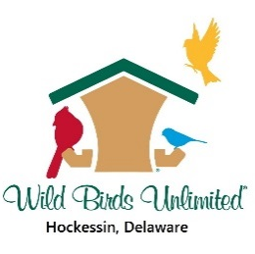
Pick some out for your own yard at:
Gateway Garden Center
7277 Lancaster Pike
Hockessin, DE 19707
(302) 239-2727

